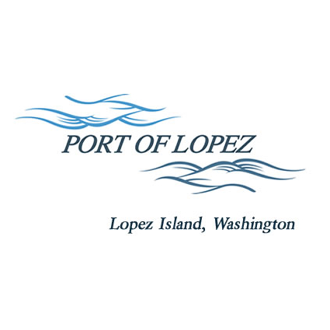

972 Airport Road, P.O. Box 907

Lopez Island, WA 98261

360.468.4116

wcatlin@portofolopez.com

www.portofolopez.com

# Port of Lopez Regular Meeting Agenda

# August 14, 2025, 4:00 P.M.

This Meeting will be on Zoom and in-person at the airport terminal

Join Zoom Meeting

https://us02web.zoom.us/j/83091809375?pwd=0T2pZabOAgaZ0hXcXeMzz6EztF7BKc.1

Meeting ID: 830 9180 9375 Passcode: 802073, One tap mobile +12532158782,,83091809375#,,,,*802073# US (Tacoma)

+12532050468,,83091809375#,,,,*802073# US

**CALL TO ORDER**

**ONGOING BUSINESS**

1. DOWL Projects:
   1. RSA/AWOS project closure
   2. Beacon tilt-down relocation cat ex update
   3. Red-line updates to September ALP/CIP
2. Blackwater updates

**PUBLIC COMMENTARY**

**MONTHLY BUSINESS**

1. Approval of Previous Minutes
2. Approval of Vouchers, Payroll, and Financial Reports

**MONTHLY REPORTS**

1. Correspondance
2. Manager’s Report
3. Commissioner’s Reports
4. Task/Project list review

**NEW BUSINESS**

1. Bayview Park Improvements

**AGENDA AMENDMENTS**

**PUBLIC COMMENTARY**

**ADJOURNMENT**

**UPCOMING MEETINGS: Regular Meeting September 11th, 2025**