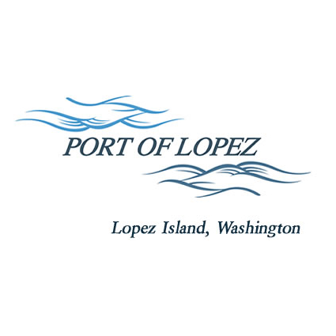

672 Airport Road, P.O. Box 907

Lopez Island, WA 98261

360.468.4116

wcatlin@portofolopez.com

www.portofolopez.com

# Port of Lopez Regular Meeting Agenda

# September 11, 2025, 4:00 P.M.

This Meeting will be on Zoom and in-person at the airport terminal

Join Zoom Meeting

https://us02web.zoom.us/j/83091809375?pwd=0T2pZabOAgaZ0hXcXeMzz6EztF7BKc.1

Meeting ID: 830 9180 9375

Passcode: 802073

**CALL TO ORDER**

**ONGOING BUSINESS**

1. DOWL Projects:
   1. Beacon tilt-down project and change-order approval
   2. Updates to five-year CIP
2. Blackwater updates
3. Bayview Park Progress

**PUBLIC COMMENTARY**

**MONTHLY BUSINESS**

1. Approval of Previous Minutes
2. Approval of Vouchers, Payroll, and Financial Reports

**MONTHLY REPORTS**

1. Correspondence
2. Manager’s Report
3. Commissioner’s Reports
4. Task/Project list review

**NEW BUSINESS**

Hangar Waiting List Policy Discussion

Establishing Minimum Balances in AP and PR accounts to avoid fees, with resolution to be passed if the board elects to maintain the minimums.

**AGENDA AMENDMENTS**

**PUBLIC COMMENTARY**

**ADJOURNMENT**

**UPCOMING MEETINGS: Regular Meeting October 9th, 2025**