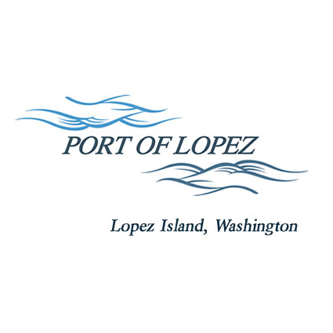

672 Airport Road, P.O. Box 907
Lopez Island, WA 98261
360.468.4116
wcatlin@portofolopez.com
www.portofolopez.com

Port of Lopez Regular Monthly Meeting Agenda

April 9th, 2026, 4:30 P.M.

This Meeting will be on Zoom and in-person at the airport terminal
Join Zoom Meeting
https://us02web.zoom.us/j/83113972306?pwd=xFXHx9llh2dAx0m8E3uAD71gL8TRkw.1
Meeting ID: 831 1397 2306
Passcode: 461983

CALL TO ORDER

PUBLIC HEARING TO APPROVE BARS codes updates to 2026 Budget.

Public Commentary

Close of Public Hearing

ONGOING BUSINESS
- DOWL Projects
- Blackwater updates
- Saddleback Ranch Clean-up
- SAO Audit exit meeting recap and notes

Public Commentary

MONTHLY BUSINESS
- Approval of Previous Minutes
- Approval of Vouchers, Payroll, and Financial Reports

MONTHLY REPORTS
- Correspondence
- Manager’s Report
- Commissioner’s Reports

NEW BUSINESS (none at this time)

AGENDA AMENDMENTS

Public Commentary

ADJOURNMENT: Next Regular Meeting May 14th, 2026

