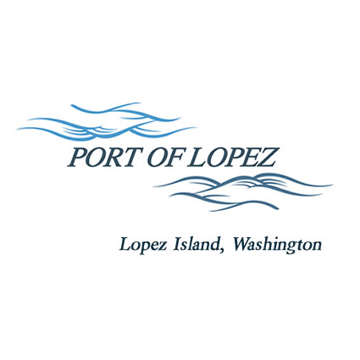

672 Airport Road, P.O. Box 907
Lopez Island, WA 98261
360.468.4116
wcatlin@portofolopez.com
www.portofolopez.com

Port of Lopez Regular Monthly Meeting Agenda

February 12th, 2026, 4:30 P.M.

This Meeting will be on Zoom and in-person at the airport terminal
Join Zoom Meeting
https://us02web.zoom.us/j/89601552758?pwd=lT3s54rnsYMKqVma1Q4mdNRgdCDn6t.1

Meeting ID: 896 0155 2758
Passcode: 734267

CALL TO ORDER

ONGOING BUSINESS
- DOWL Projects
- Blackwater updates
- Bayview Park updates

Public Commentary

MONTHLY BUSINESS
- Approval of Previous Minutes
- Approval of Vouchers, Payroll, and Financial Reports

MONTHLY REPORTS
- Correspondence
- Manager’s Report
- Commissioner’s Reports
- Task/Project list review

NEW BUSINESS

            - Approve DOWL scope document for FAA seal coat project
            - Ultimate RPZ and ALP updates in advance of FAA meeting

Public Commentary

AGENDA AMENDMENTS

ADJOURNMENT: Next Regular Meeting March 12th, 2026

