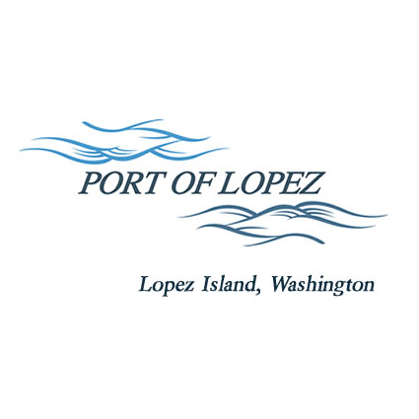

672 Airport Road, P.O. Box 907
Lopez Island, WA 98261
360.468.4116
wcatlin@portofolopez.com
www.portofolopez.com

Port of Lopez Regular Monthly Meeting Agenda

January 8th, 2026, 4:00 P.M.

This Meeting will be on Zoom and in-person at the airport terminal
Join Zoom Meeting
https://us02web.zoom.us/j/81689244765?pwd=OD7M9QWa9jFDQPh1rzwunjaBaaQH1A.1

Meeting ID: 816 8924 4765
Passcode: 094943

CALL TO ORDER

ONGOING BUSINESS
- DOWL Projects
- Blackwater updates
- Bayview Park updates

Public Commentary

MONTHLY BUSINESS
- Approval of Previous Minutes
- Approval of Vouchers, Payroll, and Financial Reports

MONTHLY REPORTS
- Correspondence
- Manager’s Report
- Commissioner’s Reports
- Task/Project list review

NEW BUSINESS

            - Hangar rental fee calibration
            - Establish reasonable lease non-renewal notice period

Public Commentary

AGENDA AMENDMENTS

ADJOURNMENT: Next Regular Meeting February 12th, 2026

