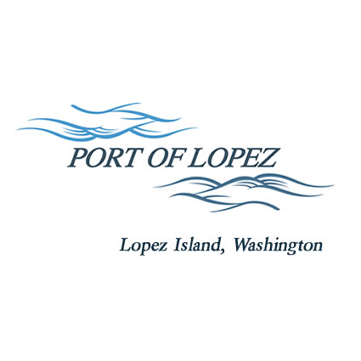

672 Airport Road, P.O. Box 907
Lopez Island, WA 98261
360.468.4116
wcatlin@portofolopez.com
www.portofolopez.com

Port of Lopez Regular Monthly Meeting Agenda

March 5th, 2026, 4:30 P.M.

This Meeting will be on Zoom and in-person at the airport terminal
Join Zoom Meeting
https://us02web.zoom.us/j/88424769962?pwd=6ebSeLbhlg2c7DmrZSFYdmKlh6p5dv.1

Meeting ID: 884 2476 9962
Passcode: 400569

CALL TO ORDER

ONGOING BUSINESS
- DOWL Projects
- Blackwater updates
- Bayview Park updates
- Hangar and Storage Rental Rate Increase

Public Commentary

MONTHLY BUSINESS
- Approval of Previous Minutes
- Approval of Vouchers, Payroll, and Financial Reports

MONTHLY REPORTS
- Correspondence
- Manager’s Report
- Commissioner’s Reports

NEW BUSINESS

            - Approve management plan for Saddleback Ranch, Don Burt dumping on public lands
            - Approve Resolution 2026-1 for FAA/WASHDOT Seal coat and runway maintenance project
            - Decide Airport Day Weekend date

Public Commentary

AGENDA AMENDMENTS

ADJOURNMENT: Next Regular Meeting April 9th, 2026

