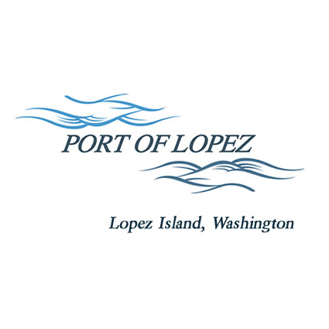

672 Airport Road, P.O. Box 907
Lopez Island, WA 98261
360.468.4116
wcatlin@portofolopez.com
www.portofolopez.com

Port of Lopez Regular Monthly Meeting Agenda

May 14th, 2026, 4:30 P.M.

This Meeting will be on Zoom and in-person at the airport terminal
Join Zoom Meeting
https://us02web.zoom.us/j/89644154684?pwd=wjsUaEFOWdX91eqmqmwnKVkEINIHAp.1

Meeting ID: 896 4415 4684
Passcode: 300584

CALL TO ORDER

AGENDA AMENDMENTS

ONGOING BUSINESS
- DOWL Projects
- Blackwater updates
- Saddleback Ranch Clean-up

Public Commentary

MONTHLY BUSINESS
- Approval of Previous Minutes
- Approval of Vouchers, Payroll, and Financial Reports

MONTHLY REPORTS
- Correspondence
- Manager’s Report
- Commissioner’s Reports

NEW BUSINESS

- Determine response to North Hangar owners who are in violation of the active aircraft requirement.
- Motion to accept FAA Grant S31-NMG-3-53-0037-022-2026 for the pavement project this Summer.
- Discuss rental of North Pasture property.

Public Commentary

ADJOURNMENT: Next Regular Meeting June 11th, 2026

