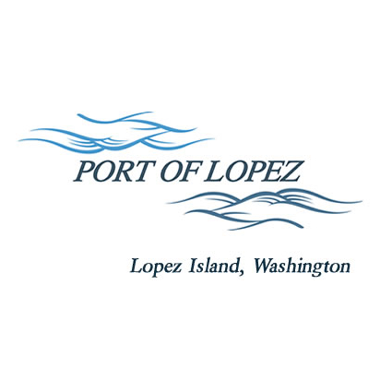

672 Airport Road, P.O. Box 907
Lopez Island, WA 98261
360.468.4116
wcatlin@portofolopez.com
www.portofolopez.com

Port of Lopez Regular Monthly Meeting Agenda

July 9th, 2026, 4:30 P.M.

This Meeting will be on Zoom and in-person at the airport terminal
Join Zoom Meeting
https://us02web.zoom.us/j/85266700706?pwd=iWilYIlaA0FAbwF8YET06dvs1dqc99.1

Meeting ID: 852 6670 0706
Passcode: 896586

CALL TO ORDER

AGENDA AMENDMENTS

ONGOING BUSINESS
- DOWL Projects
- Blackwater updates

Public Commentary

MONTHLY BUSINESS
- Approval of Previous Minutes
- Approval of Vouchers, Payroll, and Financial Reports

MONTHLY REPORTS
- Correspondence
- Manager’s Report
- Commissioner’s Reports
- Task List Review

NEW BUSINESS

- Review applications for North Pasture lease
- Review 90% Design drawings and timeline proposal for Seal Coat project

Public Commentary

ADJOURNMENT: Next Regular Meeting August 13th, 2026

